DBMS Practical No.: 13

**Name: yash ajay magar**

**Experiment No 13: Implement queries using Date and Time functions**

Exercise:

1. Write output of the following queries.

a. Select sysdate from Dual;

b. Select last_day() from Dual;

c. Select dayofweek() from Dual;

d. Select last_day(sysdate) from Dual;

e. Select monthnow() from Dual;

a. Select sysdate from Dual;

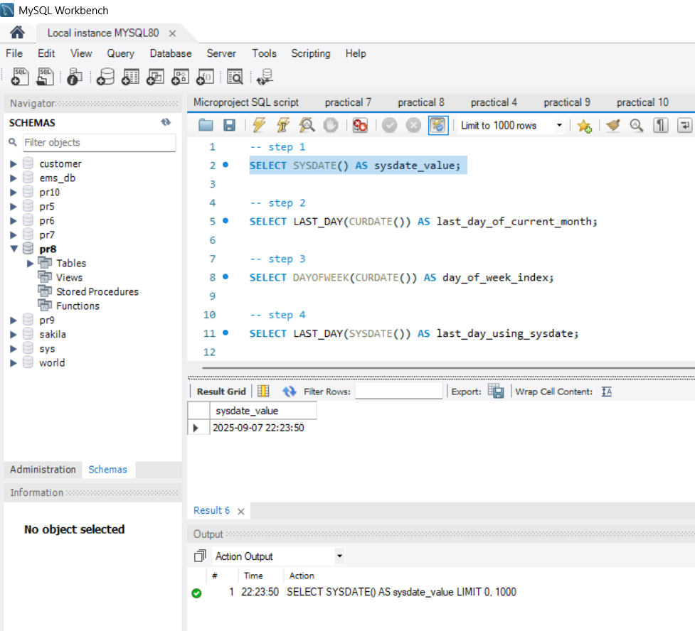

b. Select last_day() from Dual;

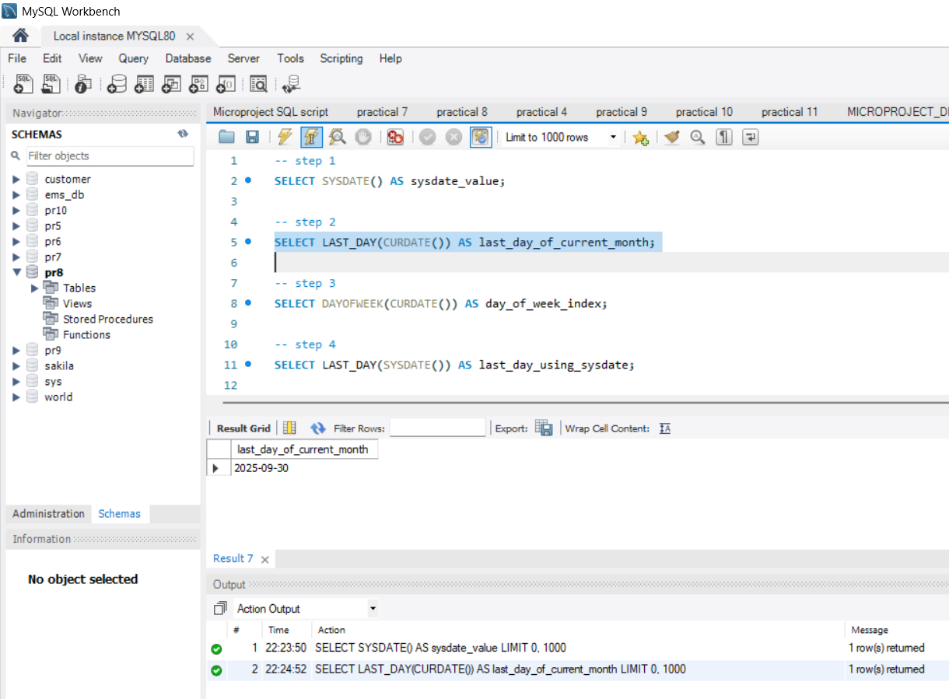

c. Select dayofweek() from Dual;

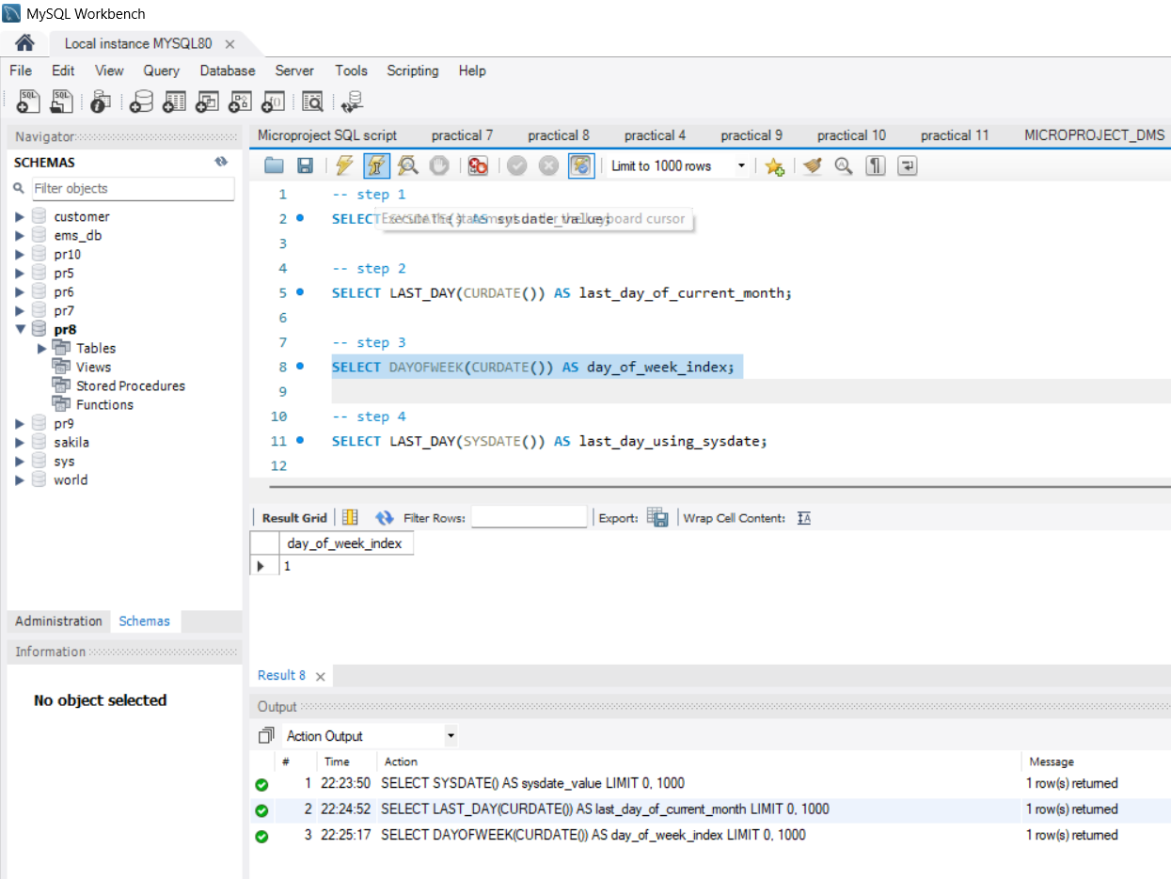

d. Select last_day(sysdate) from Dual;

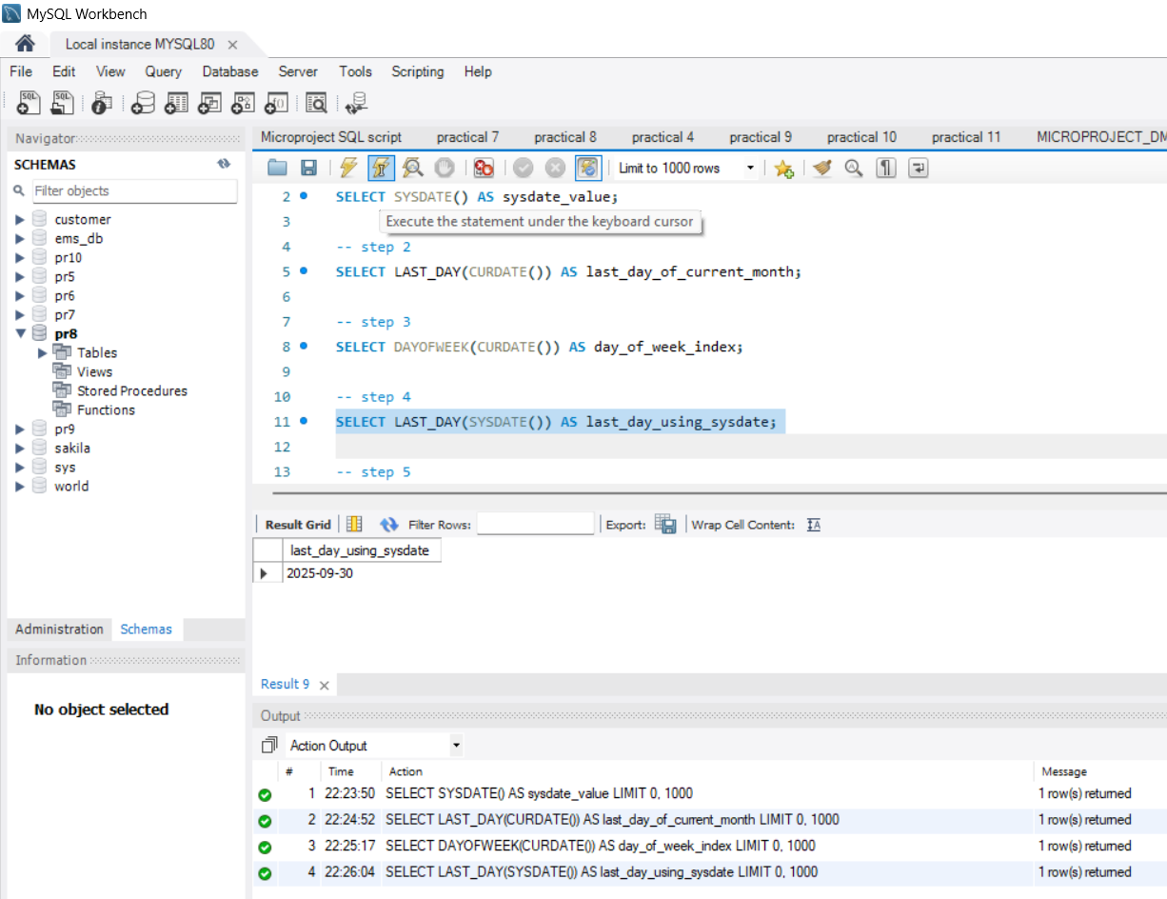

e. Select monthnow() from Dual;

